import pandas as pd import matplotlib.pyplot as plt import seaborn as sns df = pd.read_csv('day.csv') df.head()

**instant**

**dteday**

**season**

**yr**

**mnth**

**holiday**

**weekday**

**workingday**

**weathersit**

**temp**

**atemp**

**hum**

**windspeed**

**casual**

**registered**

**cnt**

**0**

1

01-01-2011

1

0

1

0

6

0

2

0.344167

0.363625

0.805833

0.160446

331

654

985

1. 2 02-01-2011 1 0 1 0 0 0 2 0.363478 0.353739 0.696087 0.248539 131 670 801
2. 3 03-01-2011 1 0 1 0 1 1 1 0.196364 0.189405 0.437273 0.248309 120 1229 1349
3. 4 04-01-2011 1 0 1 0 2 1 1 0.200000 0.212122 0.590435 0.160296 108 1454 1562
4. 5 05-01-2011 1 0 1 0 3 1 1 0.226957 0.229270 0.436957 0.186900 82 1518 1600

**Next steps:**

**Generate code with**

df

**View recommended plots**



**New interactive sheet**

print(df.shape) df.info() print(df.isnull().sum()) df.describe()

(731, 16)

<class 'pandas.core.frame.DataFrame'>

RangeIndex: 731 entries, 0 to 730 Data columns (total 16 columns):

# Column Non-Null Count Dtype

--- ------ -------------- -----

1. instant 731 non-null int64
2. dteday 731 non-null object
3. season 731 non-null int64
4. yr 731 non-null int64
5. mnth 731 non-null int64
6. holiday 731 non-null int64
7. weekday 731 non-null int64
8. workingday 731 non-null int64
9. weathersit 731 non-null int64
10. temp 731 non-null float64
11. atemp 731 non-null float64
12. hum 731 non-null float64
13. windspeed 731 non-null float64
14. casual 731 non-null int64
15. registered 731 non-null int64 15 cnt 731 non-null int64 dtypes: float64(4), int64(11), object(1) memory usage: 91.5+ KB instant 0 dteday 0 season 0 yr 0 mnth 0 holiday 0 weekday 0 workingday 0 weathersit 0 temp 0 atemp 0 hum 0 windspeed 0 casual 0 registered 0 cnt 0 dtype: int64

**instant season yr mnth holiday weekday workingday weathersit temp atemp hum windspeed casual registered**

|  |  |  |  |  |  |  |  |  |  |  |  |  |  |  |  |
| --- | --- | --- | --- | --- | --- | --- | --- | --- | --- | --- | --- | --- | --- | --- | --- |
| **count** | 731.000000 | 731.000000 | 731.000000 | 731.000000 | 731.000000 | 731.000000 | 731.000000 | 731.000000 | 731.000000 | 731.000000 | 731.000000 | 731.000000 | 731.000000 | 731.000000 | 731. |
| **mean** | 366.000000 | 2.496580 | 0.500684 | 6.519836 | 0.028728 | 2.997264 | 0.683995 | 1.395349 | 0.495385 | 0.474354 | 0.627894 | 0.190486 | 848.176471 | 3656.172367 | 4504. |
| **std** | 211.165812 | 1.110807 | 0.500342 | 3.451913 | 0.167155 | 2.004787 | 0.465233 | 0.544894 | 0.183051 | 0.162961 | 0.142429 | 0.077498 | 686.622488 | 1560.256377 | 1937. |
| **min** | 1.000000 | 1.000000 | 0.000000 | 1.000000 | 0.000000 | 0.000000 | 0.000000 | 1.000000 | 0.059130 | 0.079070 | 0.000000 | 0.022392 | 2.000000 | 20.000000 | 22. |
| **25%** | 183.500000 | 2.000000 | 0.000000 | 4.000000 | 0.000000 | 1.000000 | 0.000000 | 1.000000 | 0.337083 | 0.337842 | 0.520000 | 0.134950 | 315.500000 | 2497.000000 | 3152. |
| **50%** | 366.000000 | 3.000000 | 1.000000 | 7.000000 | 0.000000 | 3.000000 | 1.000000 | 1.000000 | 0.498333 | 0.486733 | 0.626667 | 0.180975 | 713.000000 | 3662.000000 | 4548. |
| **75%** | 548.500000 | 3.000000 | 1.000000 | 10.000000 | 0.000000 | 5.000000 | 1.000000 | 2.000000 | 0.655417 | 0.608602 | 0.730209 | 0.233214 | 1096.000000 | 4776.500000 | 5956. |
| **max** | 731.000000 | 4.000000 | 1.000000 | 12.000000 | 1.000000 | 6.000000 | 1.000000 | 3.000000 | 0.861667 | 0.840896 | 0.972500 | 0.507463 | 3410.000000 | 6946.000000 | 8714. |

df['dteday'] = pd.to_datetime(df['dteday'], errors='coerce')

plt.figure(figsize=(12, 6)) plt.plot(df['dteday'], df['cnt'], label='Total Rentals', color='green') plt.title('Bike Rentals Over Time') plt.xlabel('Date') plt.ylabel('Count') plt.grid(True) plt.legend() plt.show()

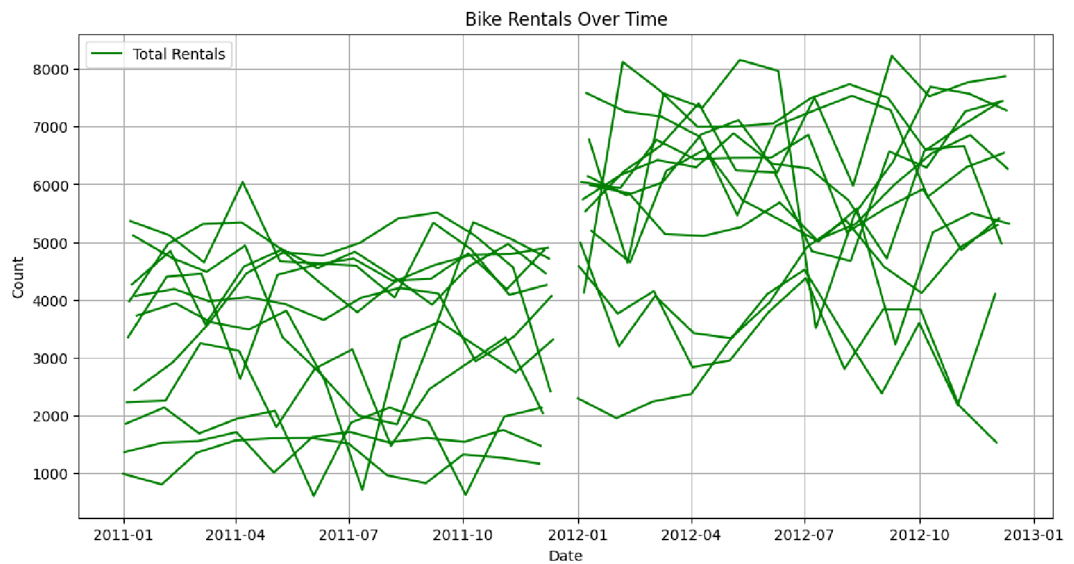

**

**

season_map = {1: 'Spring', 2: 'Summer', 3: 'Fall', 4: 'Winter'} df['season'] = df['season'].map(season_map)

plt.figure(figsize=(8, 5)) sns.barplot(data=df, x='season', y='cnt') plt.title('Average Rentals by Season') plt.show()

plt.figure(figsize=(8, 5)) sns.barplot(data=df, x='weekday', y='cnt') plt.title('Average Rentals by Weekday') plt.show()

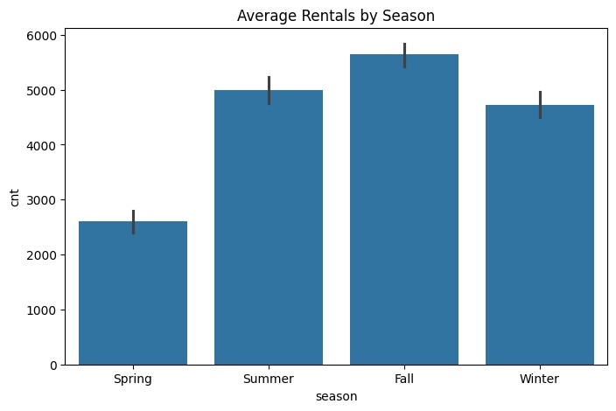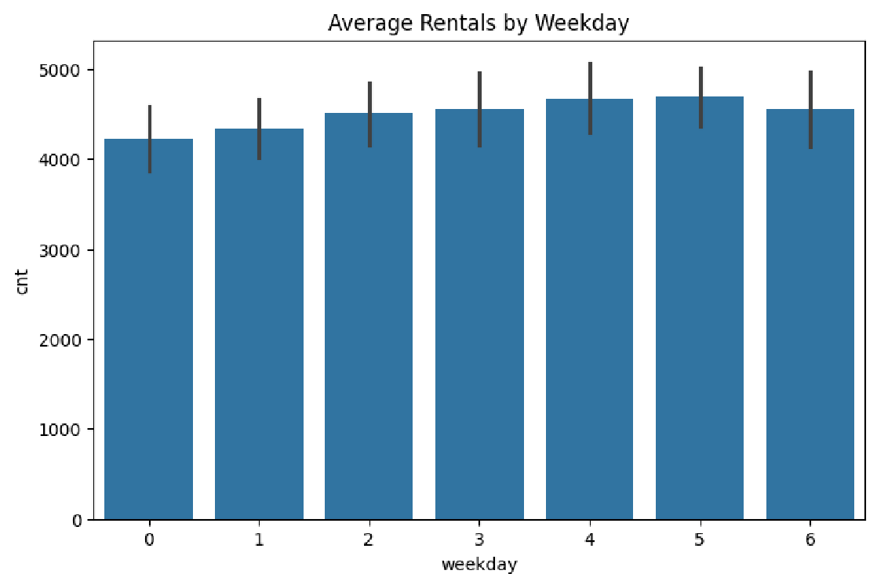

**

**

plt.figure(figsize=(14, 4))

plt.subplot(1, 3, 1) sns.scatterplot(data=df, x='temp', y='cnt') plt.title('Temperature vs Rentals')

plt.subplot(1, 3, 2) sns.scatterplot(data=df, x='hum', y='cnt') plt.title('Humidity vs Rentals') plt.subplot(1, 3, 3) sns.scatterplot(data=df, x='windspeed', y='cnt') plt.title('Windspeed vs Rentals')

plt.tight_layout() plt.show()

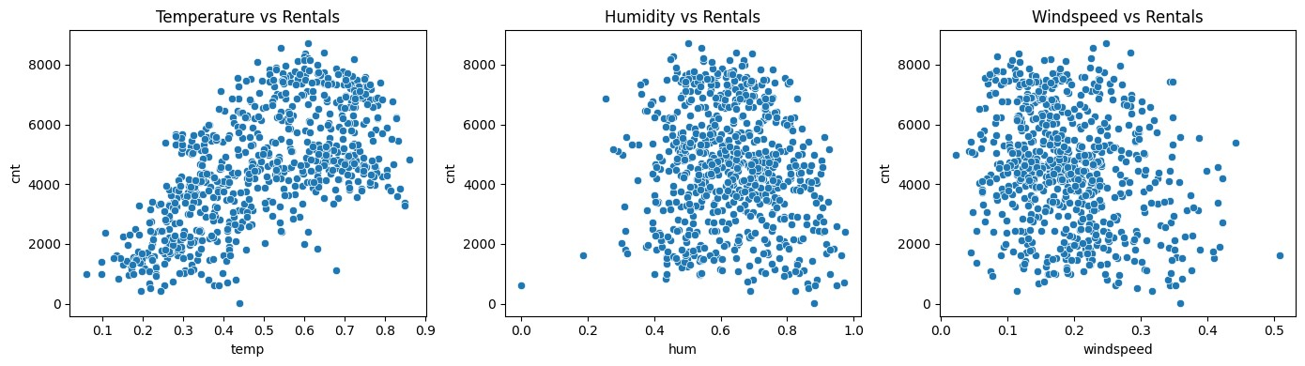

**

**

plt.figure(figsize=(10, 6)) corr = df[['temp', 'atemp', 'hum', 'windspeed', 'cnt']].corr() sns.heatmap(corr, annot=True, cmap='coolwarm') plt.title('Correlation Heatmap') plt.show()





